LandscapeBuilder Usage Guide

The goal of this program is to automate the creation of “synthetic” textured landscapes for the Condor V2 soaring simulator. It is recommended that the user of this program be familiar with the Condor Landscape Guide before usage, as the LandscapeBuilder essentially picks up on page 30 of that document and automates through page 37. Rather than building the textures by hand as described in the Condor Landscape Guide, the LandscapeBuilder scans each of the mask images and applies textures to the tile, adjusts the alpha channel for water, generates the forest maps, and generates the thermal map. By default LandscapeBuilder will then generate the final outputs used by Condor: the DDS files from nvdxt.exe, the .for forest files (along with the .fha hash file), and the .tdm thermal file. This removes the need to use the LandscapeEditor for those tasks.

Prerequisites

- The masks must be PNGs generated for each tile, 8192x8192 pixels, and properly named for the tile position. See Appendix A for a method to do this using QGIS’s Atlas feature.
- .NET Framework 4.7.2 is required.
- A 64-bit operating system is required.
- Nvdxt.exe is used to generate the DDS files. It must be either be placed in the same directory as the LandscapeBuilder executables or set up in the Path environment variable.
- LandscapeEditor.exe is used to generate the hash files. It must either be placed in the same directory as the LandscapeBuilder executables or set up in the Path environment variable.

Setting up the textures

When LandscapeBuilder is first run, some default textures will be visible. The default “Map Color” used for the masks are select colors from the National Land Cover Database, along with some other reasonable defaults. The actual textures distributed with LandscapeBuilder are from the “How in the World?” texture pack by Jenna Fearon. Refer to the diagram below for information on setting up the textures for your landscape.
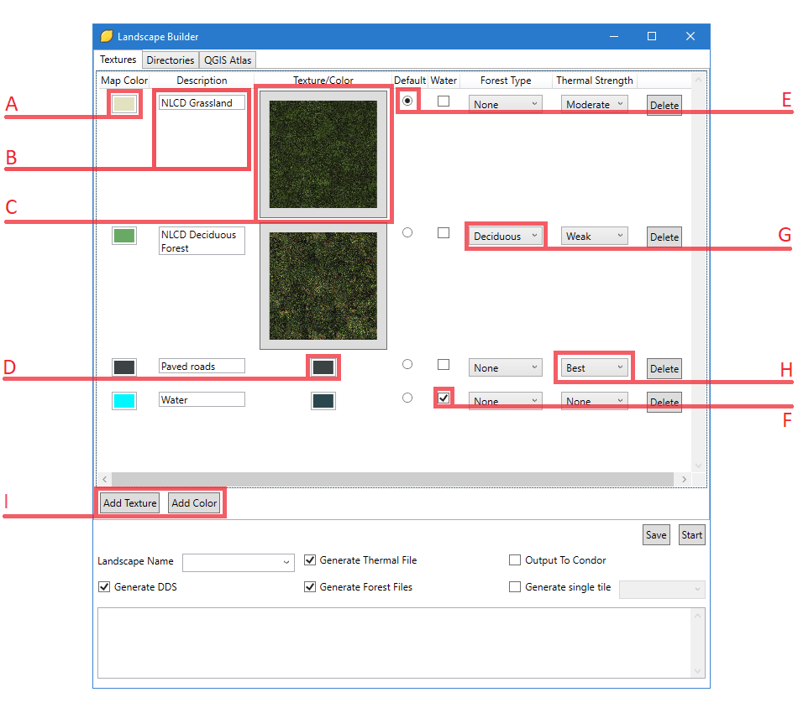

- Map Color: This is the color from the mask that the texture or color under Texture/Color will be applied to. Map Colors cannot be duplicates of each other.
- Description: This is a display only value that does not effect the output of LandscapeBuilder, but does help with managing the textures.
- Color/Texture – Texture: A thumbnail of the texture that will be applied to the Map Color. Click on it to open a file browser to select a different texture. Note: LandscapeBuilder will automatically tile the textures, there is no need to manually tile them across the entire Condor tile. There is no specific size requirement for textures selected.
- Color/Texture – Color: The color that should be applied to the Map Color. This is useful for features such as roads that are too small to properly texture and features such as water where a texture is unnecessary.
- Default: A single texture may be selected as the default. Default textures will be applied when a color is encountered in the mask tile that does not correspond to one of the defined Map Colors.
- Water: If this is checked, LandscapeBuilder will modify the alpha channel of the texture so that Condor’s water rendering will be used.
- Forest Type: This value is used for creating the forest maps.
- Thermal Strength: This value is used for creating the thermal map. The different options are not currently configurable. The colors used for the map are as follows: None – 0x000000; Weak – 0x404040; Moderate – 0x666666; Best – 0xB2B2B2.
- Add Texture/Add Color: Use these buttons to add new texture/color definitions. The new definition will be added to the bottom of the list with some default options for all of the values.

When the Save button is clicked, the texture configuration is stored in %LOCALAPPDATA%\LandscapeBuilder\textures.conf. Although the JSON format used is generally human readable, it is not recommended to modify textures.conf outside of LandscapeBuilder.

Setting up the directories

The Directories tab allows for the configuration of the Input and Output directories. The Input directory specifies the location of the mask tiles that are to be processed by LandscapeBuilder. The Output directory specifies the location of where the outputs created by LandscapeBuilder should be written to.

When the Save button is clicked, the directories are stored in %LOCALAPPDATA%\LandscapeBuilder\directories.conf. Although the JSON format used is generally human readable, it is not recommended to modify directories.conf outside of LandscapeBuilder.

Output Options

- Landscape Name: This dropdown is automatically populated from the Condor Landscapes directory. Select or enter the landscape that the textures are being generated for. The text in the box will be used to name certain output files (for example, the .tdm thermal file) and, if the “Output to Condor” option is used, to determine which directory to use for the final outputs.
- Generate DDS: If this option is checked, nvdxt.exe will be used to generate the final .DDS texture files.
- Generate Thermal File: If this option is checked, the final .tdm thermal file will be created.
- Generate Forest Files: If this option is checked, the final .for forest map files will be created. LandscapeEditor will then automatically be used to generate new hashes.
- Output To Condor: If this option is checked, the final outputs listed above will be written directly to the Landscape directory for the landscape defined in Landscape Name. If it is not checked, the final outputs will be written to a “Final” directory in the Output directory defined on the Directories tab.
- Generate single tile: If this option is checked, only the tile selected in the drop-down will be generated. This option is useful for quickly verifying that the textures and colors are set up to your liking, rather than waiting the potentially hours required to generate the complete landscape. Note: if you have previously run LandscapeBuilder for the entire landscape, you will need to delete the [Output Directory]\Textures\Patches directory before using this option. Otherwise, nvdxt.exe will still generate textures for the entire landscape.
Appendix A

This appendix describes how to set up a QGIS Print Layout in order to generate the tiles that will be used to build the landscape. Once you have the QGIS project is set up with all of the land data that is required, follow these steps to create the tiles. This guide will demonstrate the process using a landscape that encompasses Central and Southeast Virginia in the US.

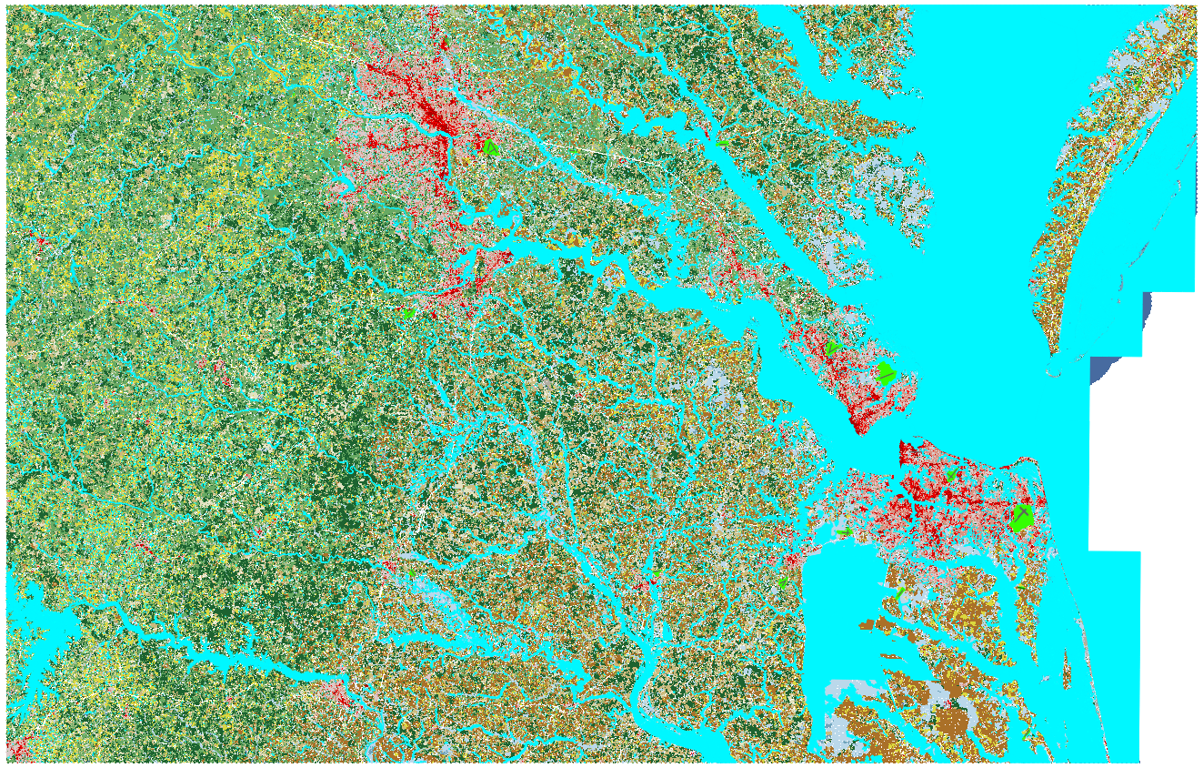

- Create a grid vector that will be used as the Coverage layer for the Atlas.
  - Select Vector→Research Tools→Create Grid
  - For Grid Type, select “Rectangle (polygon)”
  - For grid extent, enter the UTM coordinates for your landscape.
  - For Horizontal and Vertical spacing, enter 23.04 kilometers.
  - Verify Grid CRS is set to your UTM zone.
  - Click Run. You should now have a grid that covers your landscape and partitions it into tiles. Verify that the correct number of tiles are displayed.
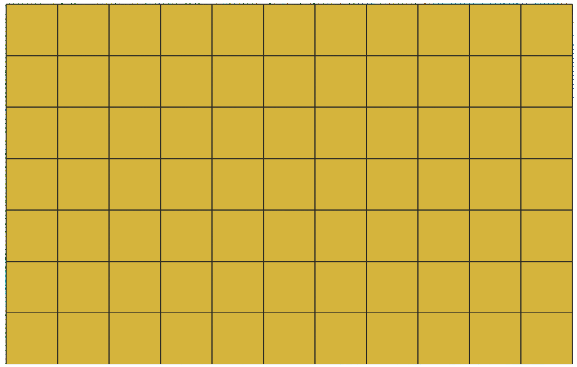

  - Uncheck the Grid so that it is not displayed.

- Create the layout.
  - Select Project→New Print Layout.
  - Right click the blank page and select “Page Properties”.
  - Under Page Size, select “Custom”.
  - Switch the units for Width and Height to pixels (“px”) and enter 8192 for both.
  - Select Add Item→New Map. Click and drag to add the map (do not worry about getting the size right).
  - With the map selected, select Item Properties.
  - For the Extents, enter the UTM coordinates for your landscape.
  - Scroll down to Position and Size. Enter 0 for both X and Y.
  - Set the units for Width and Height to pixels (“px”) and enter 8192 for both.
  - Select the Atlas tab. Check “Generate an atlas”.
  - For the Coverage layer, select the Grid that was generated above. Check off “Hidden coverage layer”.
  - Under Output, uncheck “Single file export when possible”.
  - Use the QGIS Atlas tab in LandscapeBuilder to create the array to use for naming the tiles.
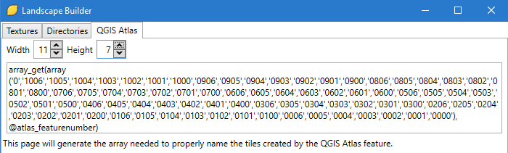
  - Copy that text into the Output filename expression.
  - Switch back to the Item Properties tab. It should still be the properties of the map.
  - Check off “Controlled by Atlas”. Set the Margin around feature to 0%.
  - Select Atlas→Preview Atlas. The view should now be of the top left tile that will be generated. The other tiles may be examined by clicking on the arrows at the top or by selecting the number in the dropdown.
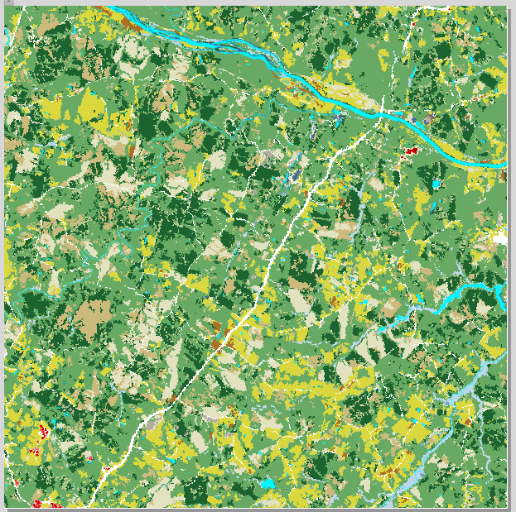

- Generate the atlas.
  - Select Atlas→Export Atlas as Images. Select the folder to output the tiles to. Make sure Page width and height are 8192 pixels. Uncheck “Enable antialiasing”. Click Save.
  - After the tiles have been exported, on the Directory tab of LandscapeBuilder, select the directory chosen above as the Input directory.

